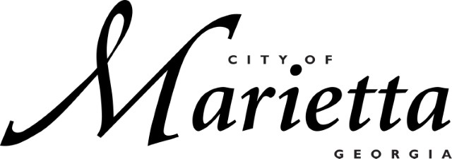
CITY OF MARIETTA HIRING EVENT

ON THE SPOT INTERVIEWS / CONDITIONAL OFFERS!

PUBLIC WORKS, PARKS & RECREATION, MARIETTA WATER, MARIETTA POWER, MARIETTA FIRE, MARIETTA PD, DEVELOPMENT SERVICES AND MORE

FRIDAY, September 15
10AM -2PM

548 South Marietta Pkwy SE, Marietta, GA 30060

