Two ways to get a Rental Return Label

1. Wait for the rental reminder email that is sent 14 days before your rental due date. Email is sent again 7 days, 3 days, and the day of your due date. This email contains a link to generate a free return shipping label and packing slip.

2. Or you can immediately generate a free return shipping label on this website, in your account:

Go to <http://www.bkstr.com/gahighlandsfloydstore> or [http://www.bkstr.com/gahighlandscarterstore](http://www.bkstr.com/gahighlandsfloydstore)

a. Click the Sign In link on the top right side of the page to sign into your account.



b. Enter the email address you provided at the register when you rented. Note: Even if you rented in the store, an account was created using the email you provided at the register.

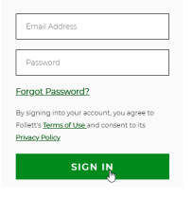

If you don’t know your password, you can click Forgot Password link for a temporary password to be emailed to you.

c. Once you’ve signed in, click the link “Rentals”. You will be navigated to the Rentals page in your account.

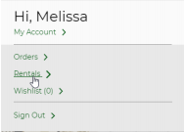

d. On Rentals page, scroll down the page to see the books you rented. Click the link “Return All Rentals by Mail”. You can also click the button “Return by Mail”. Both open a pop up to select your rentals to ship back.

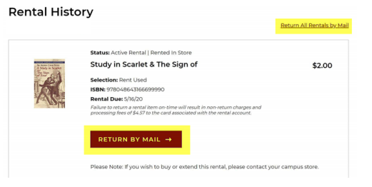

e. Follow the steps to generate and print the return label and packing slip. This option is available until your rental due date.